1. Add new application to default website

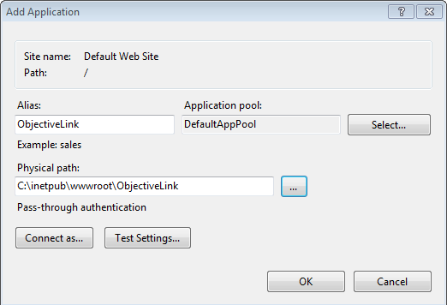

1. Open visual studio as ADMINSITRATOR
2. In visual studio right click on the project and then Publish…
3. Choose IIS, FTP, Web Deploy and hit Publish

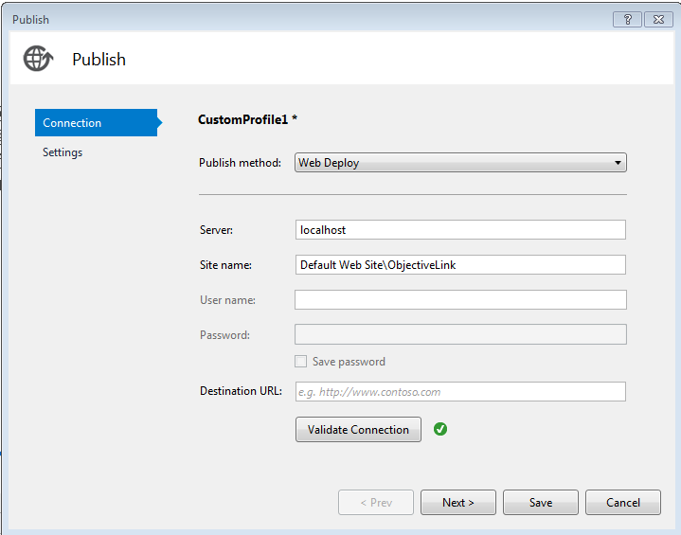

1. Hit Publish
2. Test with http://localhost/ObjectiveLink/api/Obr/fA5642034